Grp 7 :- CSE214034, CSE214035, CSE214036

Suppose using the "Optical Recognition of Handwritten Digits" database SVM classifier gives better performance, then list the tabular form such as:

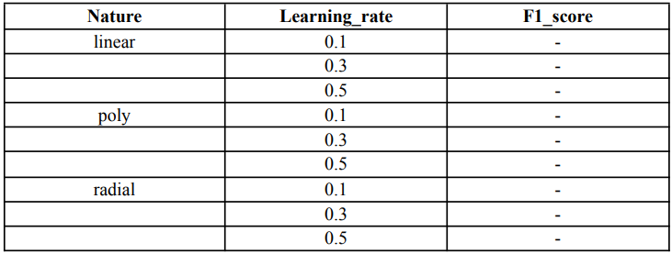

Justify what will be the best nature of the SVM classifier for that database.

Code: -

# Import necessary libraries

from sklearn import datasets

from sklearn.model_selection import train_test_split

from sklearn.svm import SVC

from sklearn.metrics import f1_score

import pandas as pd

# Load the dataset

digits = datasets.load_digits()

X, y = digits.data, digits.target

# Split the data into training and testing sets

X_train, X_test, y_train, y_test = train_test_split(X, y, test_size=0.3, random_state=42)

# Define kernel types and C (learning_rate) values

kernels = ['linear', 'poly', 'rbf']

C_values = [0.1, 0.3, 0.5]

results = []

# Train and evaluate the model for each kernel and C value

for kernel in kernels:

for C in C_values:

svm = SVC(kernel=kernel, C=C)

svm.fit(X_train, y_train)

# Predict and evaluate the model

y_pred = svm.predict(X_test)

f1 = f1_score(y_test, y_pred, average='weighted')

# Append results

results.append({'Nature': kernel, 'Learning_rate': C, 'F1_score': f1})

# Create a DataFrame to display results in tabular format

results_df = pd.DataFrame(results)

print(results_df)

Output: -

